Reebok SMART RING
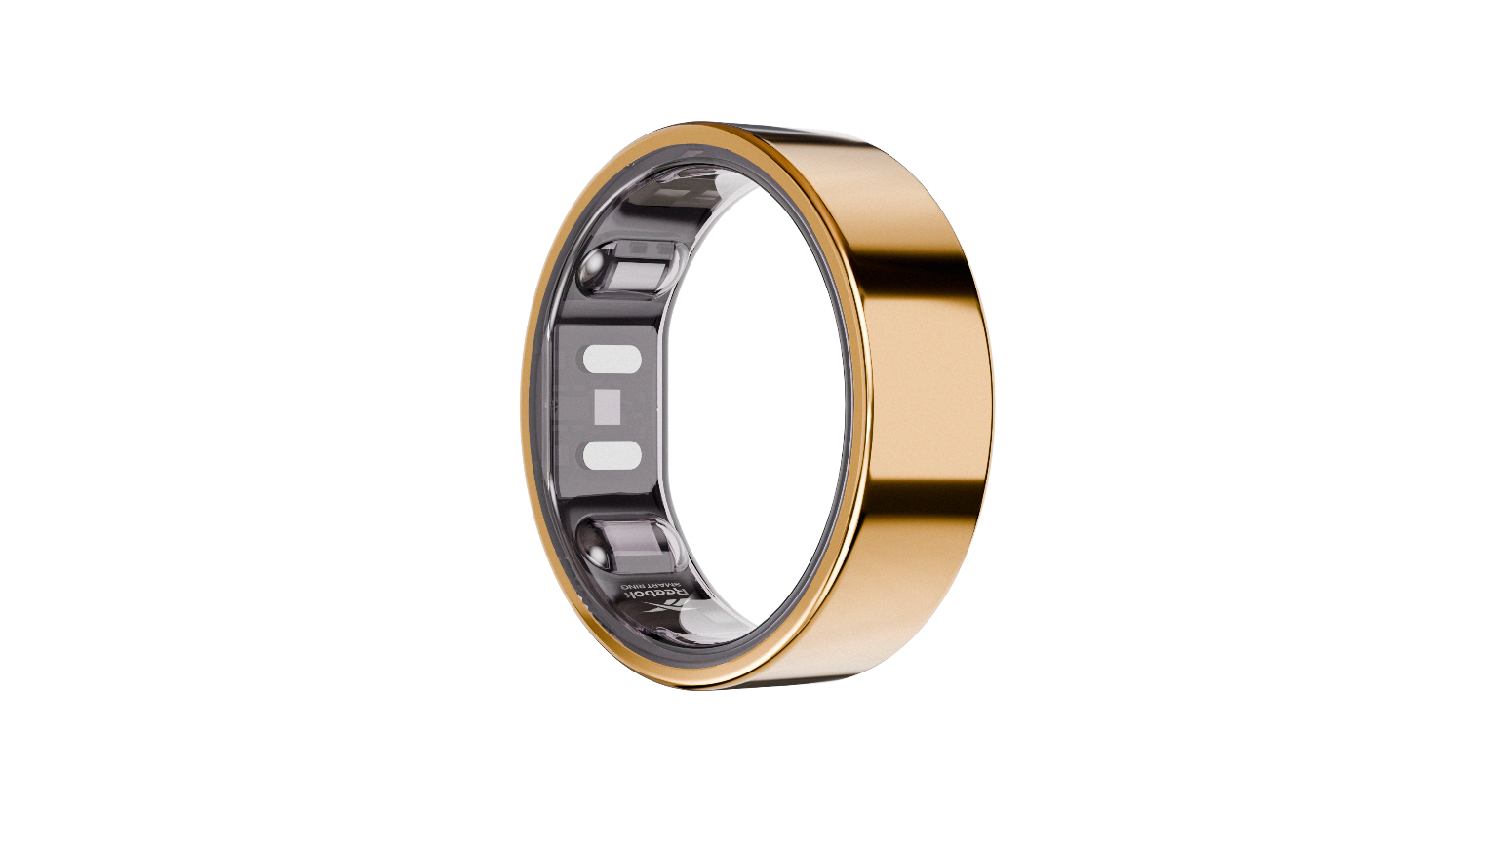
PRICE: Approximately Rs. 8,499

_{Introduction:}
The Reebok Smart Ring is a sleek, wearable device designed to track your fitness, activity, and overall health without compromising style or comfort. Compact and lightweight, this ring combines modern technology with a minimalist design, making it perfect for all-day wear. It continuously monitors key metrics such as heart rate, steps, sleep patterns, and calorie expenditure, providing you with actionable insights to improve your health and performance. Ideal for athletes, fitness enthusiasts, and anyone who wants to maintain an active lifestyle, the Reebok Smart Ring ensures you stay connected to your wellness goals in a convenient, hands-free way.
Product Overview:
The Reebok Smart Ring is a stylish alternative to bulky fitness trackers and smartwatches. Designed with precision sensors and durable materials, it monitors your physical activity, sleep quality, and heart rate in real-time.
About the Brand:

Reebok is a globally recognized sports and fitness brand known for producing reliable, high-performance athletic gear and accessories. With decades of experience in sports innovation, Reebok products are trusted by athletes and everyday users alike for quality, durability, and practical design.

Key Features:
- Continuous heart rate monitoring
- Step counting and activity tracking
- Sleep quality and duration analysis
- Calorie burn estimation
- Water-resistant design
- Long-lasting rechargeable battery
- Lightweight and ergonomic fit

Design & Build Quality:
The Reebok Smart Ring boasts a minimalist and modern design that fits comfortably on your finger. Crafted from durable, high-quality materials, it resists scratches and daily wear while remaining lightweight. Its smooth surface ensures comfort, and the sleek finish makes it suitable for both workouts and casual wear.
Storage & Capacity:
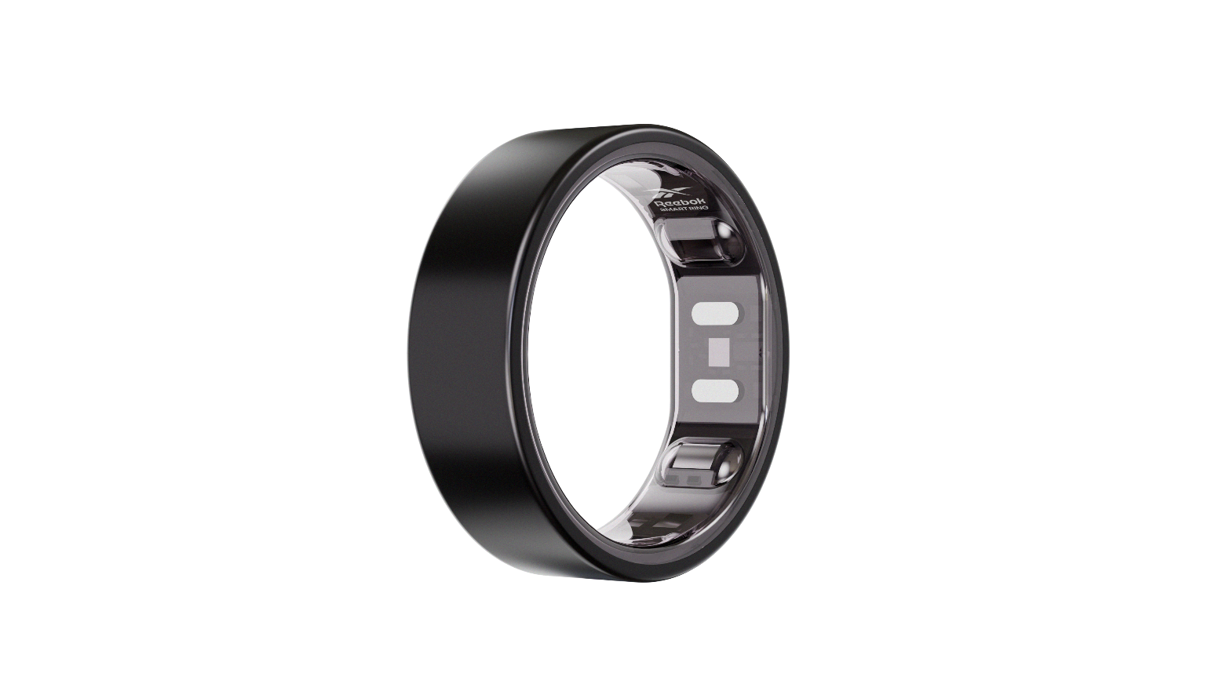
The Smart Ring stores data internally and syncs seamlessly with the Reebok mobile app via Bluetooth. It can track multiple metrics simultaneously, providing detailed activity reports without needing constant connection to a device. Its compact design ensures it fits comfortably on any finger size.

Material & Durability:
Made from premium, lightweight metals and reinforced polymers, the Reebok Smart Ring is built to last. It is water-resistant and can handle sweat, light splashes, and daily wear while maintaining performance and appearance.
Ideal For:
- Fitness enthusiasts and gym-goers
- Athletes and runners
- Users who prefer discreet wearable technology
- Individuals tracking health goals
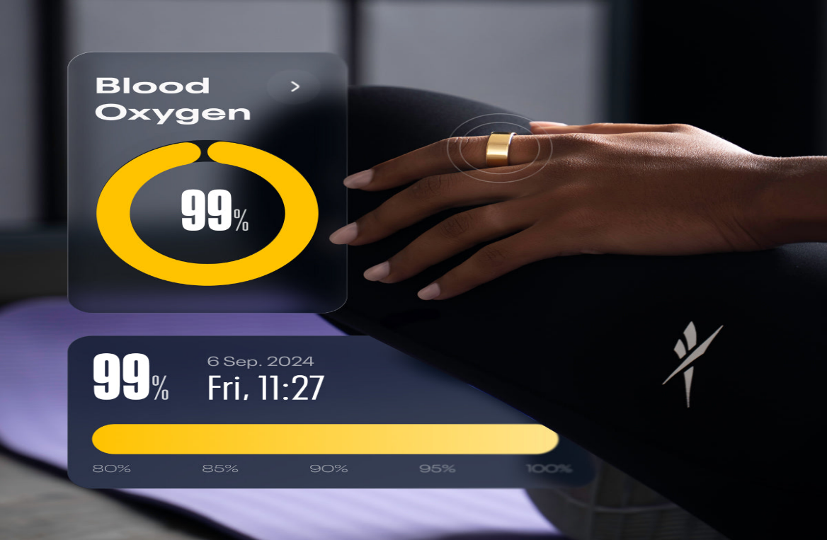

Care Instructions:
- Clean with a soft, damp cloth
- Avoid exposure to harsh chemicals
- Remove before swimming in deep water
- Store in a cool, dry place when not in use
Product Specifications:
- Brand: Reebok
- Product Type: Smart Ring/Fitness Tracker
- Sensors: Heart rate, motion, sleep tracking
- Connectivity: Bluethooth
- Battery Life: Up to 7 days per charge
- Water Resistance: Yes, splash and sweat-proof
- Sizes Available: Small, Medium,Large
Product Summary:
The Reebok Smart Ring offers a perfect balance of style, technology, and fitness tracking. Lightweight, durable, and feature-rich, it helps users monitor their health and performance effortlessly, making it an essential companion for anyone serious about wellness.

